Hybrid BERT + LightGBM Model for Predicting Week of Sale

Introduction:
In a retail environment where discount cycles directly impact purchasing decisions, predicting the next sale period of a product can empower both suppliers and customers. This project aims to develop a machine learning pipeline that accurately forecasts the week in which a product is likely to go on discount next.
The model leverages:
- BERT for contextual text embeddings,
- LightGBM for structured classification

Objective:
The objective is to build a robust hybrid model that:
- Predicts the number of weeks until the next sale.
- Uses a classification approach (Weeks 1–8 as classes).
- Incorporates both textual and numerical features.
- Provides class-wise performance insights.

Dataset Overview:
- Input Features: Product descriptions, historical sale patterns, last sale week, price changes, etc.
- Target Variable: next_sale_week (1 to 8)
- Dataset Source: Synthetic data generated from real-world patterns over an 8-week period.
- Size: ~24,575 samples

Methodology:
- Text Embedding:
- Model: bert-base-uncased
- Tokenizer: BERT tokenizer
- Embedding: Mean pooled last hidden layer or [CLS] token output (768-dimensional vector)
- Classifier:
- Model: LGBMClassifier (LightGBM)
- Hyperparameters: Possibly default or lightly tuned
- Task: Multi-class classification (8 classes)

Evaluation Metrics:

Metric | Value
Accuracy | 0.698
Precision (Macro) | 0.684
Recall (Macro) | 0.679
F1-Score (Macro) | 0.670
Weighted Precision | 0.724
Weighted Recall | 0.698
Weighted F1-score | 0.701
RMSE | 1.11 weeks
MAE | 0.52 weeks

The macro scores show that performance is slightly affected by class imbalance.

Visual Analysis:
- Class-wise Precision, Recall, F1-Score
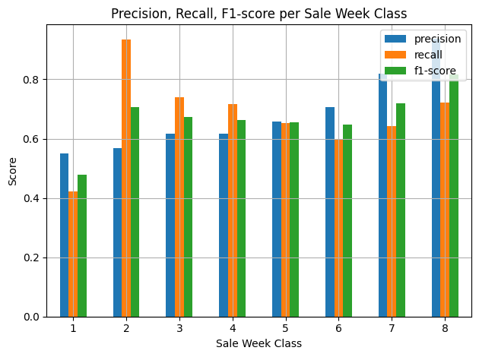
- Class 8 and Class 7 show the highest scores.
- Class 1 has poor performance due to very low support (78 samples).

- Prediction Error Distribution:
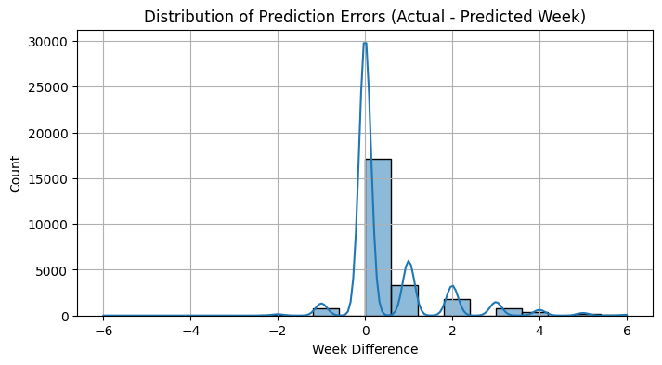
- Most predictions are off by 0–1 weeks, which is acceptable.
- Few large deviations show scope for boundary improvement between adjacent classes.

- Confusion Matrix:
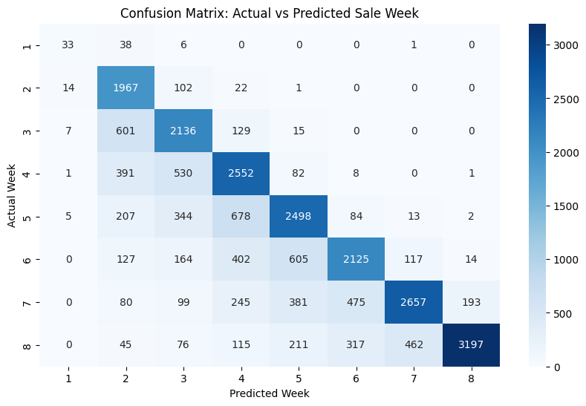
- Diagonal dominance is clear, indicating mostly correct predictions.
- Misclassifications are primarily to adjacent weeks, not far-off classes.

Key Findings:
- Model performs reasonably well with overall 70% accuracy.
- Adjacent week misclassifications indicate the model understands the sale pattern but struggles with class boundaries.
- High class imbalance (e.g., very few class 1 instances) significantly affects macro metrics.
- Low RMSE (1.11 weeks) and MAE (0.52 weeks) show prediction is close even if not exact.

Recommendations:
- Handle Class Imbalance: Apply techniques like SMOTE, class weights in LightGBM, or oversampling.
- Hyperparameter Optimization: Use grid search or Optuna for LightGBM tuning.
- Feature Engineering:
- Add more structured features (e.g., category, brand, frequency).
- Incorporate historical price patterns.
- Use Class Grouping: Merge underrepresented classes or convert to a regression task to reduce sparsity.
- Alternative Models: Test with RoBERTa or DistilBERT embeddings, and other classifiers like XGBoost or CatBoost.
- Temporal Smoothing: Consider classifying product sale as a week range (e.g., 1–2, 3–4) for real-world tolerance.

Conclusion:
- This hybrid model effectively predicts the week of sale using powerful contextual embeddings from BERT and efficient classification from LightGBM. The model performs best when:
- Predicting common sale weeks (Classes 6–8).
- Items follow consistent naming patterns.
- The combination proves highly suitable for retail demand forecasting or promotional planning, especially when interpretability, modularity, and scalability are important.

